Right Angle
# Source: AI Source: Provided by: [Data Path: Persons Table -> ID Column: 1, Name_En Column: Motasem Essam] -> From: [ChatGPT] on [7/25/2026]
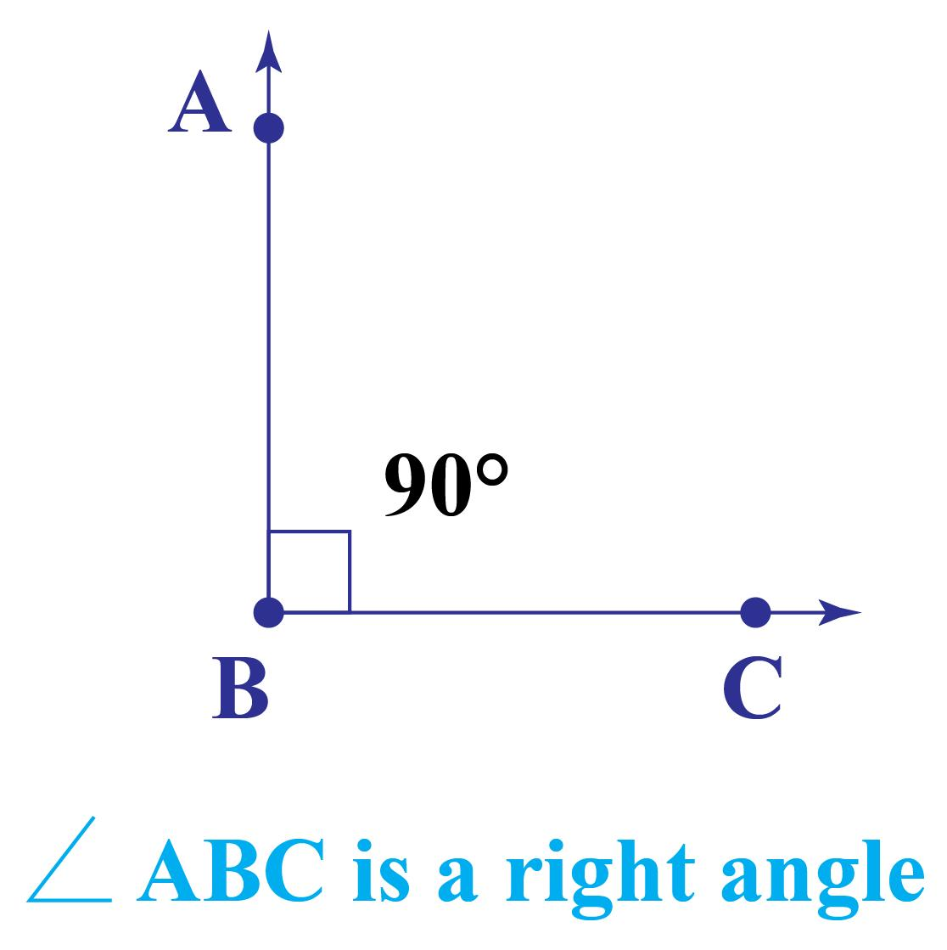
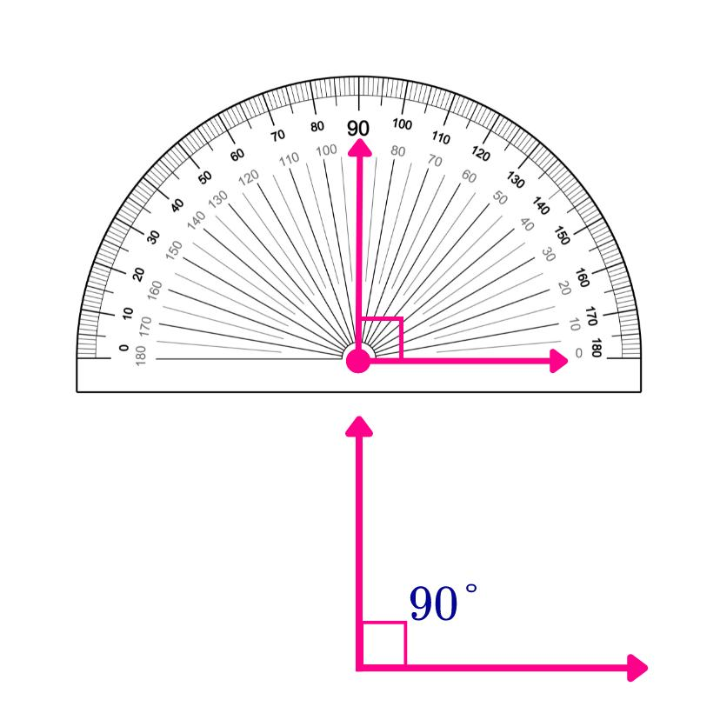
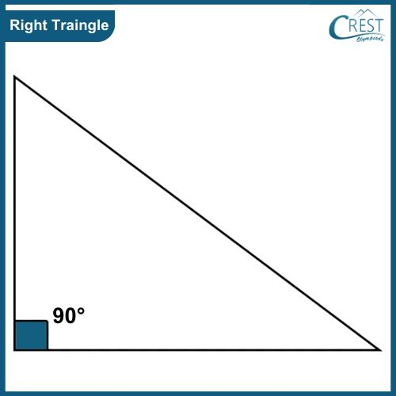
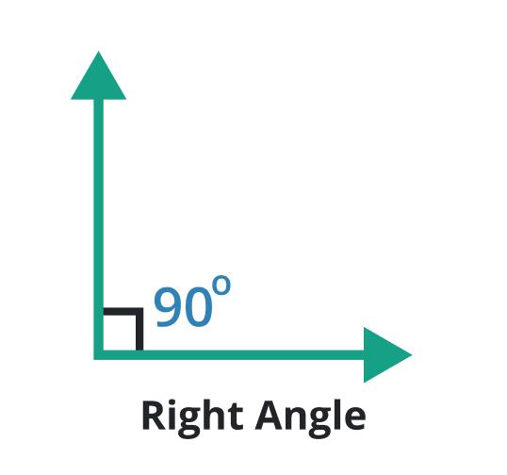
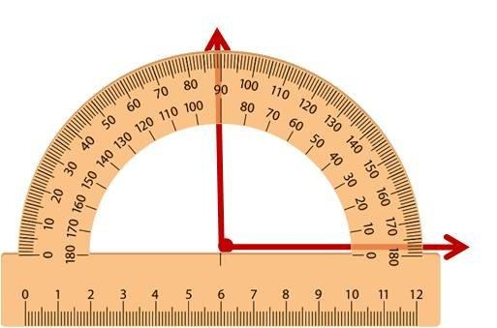
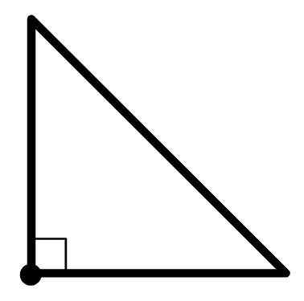

Definition
# Source: AI Source: Provided by: [Data Path: Persons Table -> ID Column: 1, Name_En Column: Motasem Essam] -> From: [ChatGPT] on [7/25/2026]
A Right Angle is an angle that measures exactly ${90}^{∘}$. It is formed when two rays, line segments, or lines intersect perpendicularly, creating a perfect square corner.
A right angle is one of the fundamental angle types in geometry and serves as the reference for classifying other angles.

Characteristics
# Source: AI Source: Provided by: [Data Path: Persons Table -> ID Column: 1, Name_En Column: Motasem Essam] -> From: [ChatGPT] on [7/25/2026]
A right angle:
- Measures exactly ${90}^{∘}$.
- Measures exactly $\frac{π}{2}$radians.
- Is formed by two rays sharing a common vertex.
- Is created by two perpendicular lines or line segments.
- Is commonly represented by a small square at the vertex.

Illustration
# Source: AI Source: Provided by: [Data Path: Persons Table -> ID Column: 1, Name_En Column: Motasem Essam] -> From: [ChatGPT] on [7/25/2026]
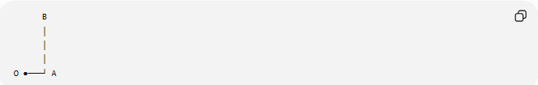
B
│
│
│
O ●───┘ A
The angle between the two rays is exactly ${90}^{∘}$.

Mathematical Representation
# Source: AI Source: Provided by: [Data Path: Persons Table -> ID Column: 1, Name_En Column: Motasem Essam] -> From: [ChatGPT] on [7/25/2026]
A right angle satisfies:
$$θ={90}^{∘}$$
or
$$θ=\frac{π}{2}\text{ radians}$$

Right-Angle Symbol
# Source: AI Source: Provided by: [Data Path: Persons Table -> ID Column: 1, Name_En Column: Motasem Essam] -> From: [ChatGPT] on [7/25/2026]
A right angle is usually indicated by a small square instead of an arc.
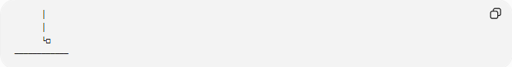
│
│
└□
────────────

Coordinate Geometry
# Source: AI Source: Provided by: [Data Path: Persons Table -> ID Column: 1, Name_En Column: Motasem Essam] -> From: [ChatGPT] on [7/25/2026]
Suppose two rays originate from
$$O\left(0 , 0\right)$$
First ray passes through
$$A\left(5 , 0\right)$$
Second ray passes through
$$B\left(0 , 5\right)$$
The rays are perpendicular, therefore
$$∠AOB={90}^{∘}$$

Slope Relationship
# Source: AI Source: Provided by: [Data Path: Persons Table -> ID Column: 1, Name_En Column: Motasem Essam] -> From: [ChatGPT] on [7/25/2026]
If two non-vertical lines have slopes
$$m_{1}$$
and
$$m_{2}$$
they are perpendicular when
$$m_{1}m_{2}=-1$$
For example,
$$m_{1}=2, m_{2}=-\frac{1}{2}$$
Since
$$2\left(-\frac{1}{2}\right)=-1$$
the lines meet at a right angle.

Real-World Examples
# Source: AI Source: Provided by: [Data Path: Persons Table -> ID Column: 1, Name_En Column: Motasem Essam] -> From: [ChatGPT] on [7/25/2026]
Right angles appear in:
- Corners of books.
- Corners of tables.
- Doors and windows.
- Floor meeting a wall.
- Squares and rectangles.
- Chessboards.
- Building corners.

Properties
# Source: AI Source: Provided by: [Data Path: Persons Table -> ID Column: 1, Name_En Column: Motasem Essam] -> From: [ChatGPT] on [7/25/2026]
A right angle:
- Measures exactly ${90}^{∘}$.
- Is formed by perpendicular lines or rays.
- Divides a straight angle into two equal parts.
- Is larger than an acute angle.
- Is smaller than an obtuse angle.

Right Angles in Polygons
# Source: AI Source: Provided by: [Data Path: Persons Table -> ID Column: 1, Name_En Column: Motasem Essam] -> From: [ChatGPT] on [7/25/2026]
Examples include:
- Every corner of a square.
- Every corner of a rectangle.
- One angle of a right triangle.
- Many engineering and architectural designs.

Applications
# Source: AI Source: Provided by: [Data Path: Persons Table -> ID Column: 1, Name_En Column: Motasem Essam] -> From: [ChatGPT] on [7/25/2026]
Right angles are used in:
- Plane Geometry
- Coordinate Geometry
- Trigonometry
- Engineering
- Architecture
- Construction
- Surveying
- CAD (Computer-Aided Design)
- Robotics
- Computer Graphics

Advantages
# Source: AI Source: Provided by: [Data Path: Persons Table -> ID Column: 1, Name_En Column: Motasem Essam] -> From: [ChatGPT] on [7/25/2026]
Studying right angles helps to:
- Construct perpendicular lines.
- Build accurate geometric figures.
- Solve trigonometric problems.
- Design precise engineering structures.
- Analyze coordinate systems.

Limitations
# Source: AI Source: Provided by: [Data Path: Persons Table -> ID Column: 1, Name_En Column: Motasem Essam] -> From: [ChatGPT] on [7/25/2026]
A right angle:
- Must measure exactly
$${90}^{∘}$$
- Any angle greater or smaller is not a right angle.

Comparison with Other Types of Angles
# Source: AI Source: Provided by: [Data Path: Persons Table -> ID Column: 1, Name_En Column: Motasem Essam] -> From: [ChatGPT] on [7/25/2026]
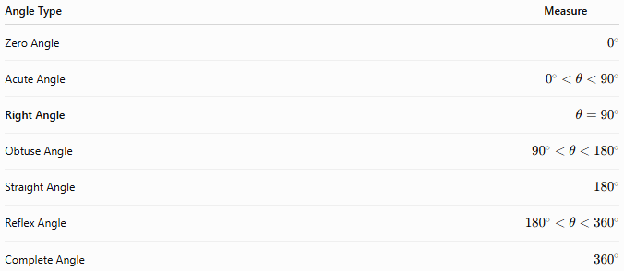
Angle Type | Measure
Zero Angle | $$0^{∘}$$
Acute Angle | $$0^{∘}<θ<{90}^{∘}$$
Right Angle | $$θ={90}^{∘}$$
Obtuse Angle | $${90}^{∘}<θ<{180}^{∘}$$
Straight Angle | $${180}^{∘}$$
Reflex Angle | $${180}^{∘}<θ<{360}^{∘}$$
Complete Angle | $${360}^{∘}$$

Key Points
# Source: AI Source: Provided by: [Data Path: Persons Table -> ID Column: 1, Name_En Column: Motasem Essam] -> From: [ChatGPT] on [7/25/2026]
- A Right Angle measures exactly:
$${90}^{∘}$$
- In radians:
$$\frac{π}{2}$$
- It is formed by perpendicular rays or lines.
- It is represented by a small square at the vertex.
- Right angles are fundamental in geometry, engineering, architecture, surveying, CAD, robotics, and computer graphics.

Conclusion
# Source: AI Source: Provided by: [Data Path: Persons Table -> ID Column: 1, Name_En Column: Motasem Essam] -> From: [ChatGPT] on [7/25/2026]
A Right Angle is an angle measuring exactly ${90}^{∘}$, formed when two rays, line segments, or lines meet perpendicularly. It serves as the standard reference for classifying other angles and is one of the most important concepts in geometry. Right angles are fundamental in plane geometry, coordinate geometry, trigonometry, engineering, architecture, construction, surveying, CAD, robotics, and computer graphics, where they are essential for constructing accurate figures, designing stable structures, and analyzing perpendicular relationships.

